NAME: K Yamini
REG NO: 192572181

Write a Python program to solve the Crypt-Arithmetic problem
Aim:
To assign digits to letters such that the given arithmetic equation is satisfied.
Algorithm:
- Take a crypt-arithmetic equation (e.g., SEND + MORE = MONEY).
- Extract all unique letters from the equation.
- Assign digits (0–9) to each letter.
- Ensure:
No two letters have the same digit.
Leading letters are not zero.
- Generate all possible permutations of digits.
- Substitute digits into the equation.
- Check if the arithmetic equation is correct.
- If correct, print the solution.
- Stop after finding valid solution(s).

Python Code:
import itertools
# Words
word1 = "SEND"
word2 = "MORE"
result = "MONEY"
# Get unique letters
letters = list(set(word1 + word2 + result))
# Function to convert word to number
def word_to_num(word, mapping):
num = 0
for letter in word:
num = num * 10 + mapping[letter]
return num
# Solve
digits = range(10)
for perm in itertools.permutations(digits, len(letters)):
mapping = dict(zip(letters, perm))
# Leading letters should not be zero
if mapping[word1[0]] == 0 or mapping[word2[0]] == 0 or mapping[result[0]] == 0:
continue
num1 = word_to_num(word1, mapping)
num2 = word_to_num(word2, mapping)
num3 = word_to_num(result, mapping)
if num1 + num2 == num3:
print("Solution Found:\n")
print("Mapping:")
for k, v in mapping.items():
print(k, "=", v)
print("\nVerification:")
print(num1, "+", num2, "=", num3)
break
Input:
Equation: SEND + MORE = MONEY
Output :
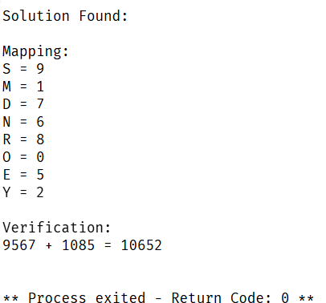
Result:
The Crypt-Arithmetic problem is solved successfully, and a valid mapping of letters to digits is obtained.

